1

2

3

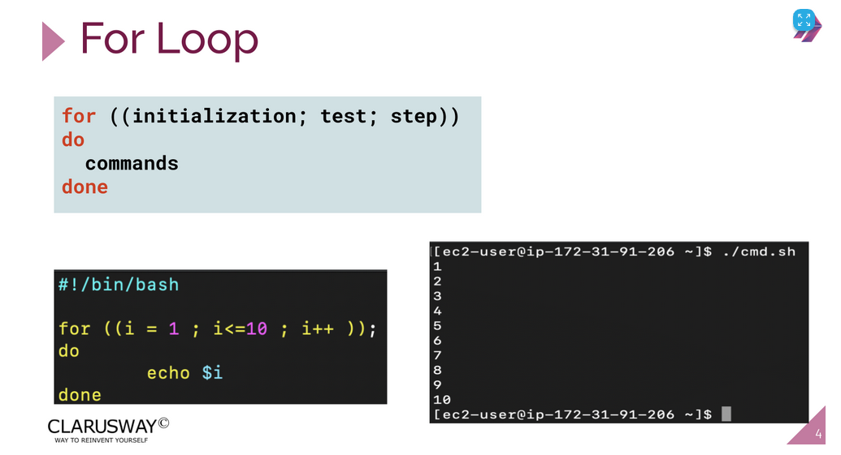

5 : 1-100 arası sayıların tıoplamı :

#!/bin/bash

sum=0

for (( num= 1; num<=100; num++ ))

do

let sum+=$num

echo "sayac: $sum toplam : $num"

done

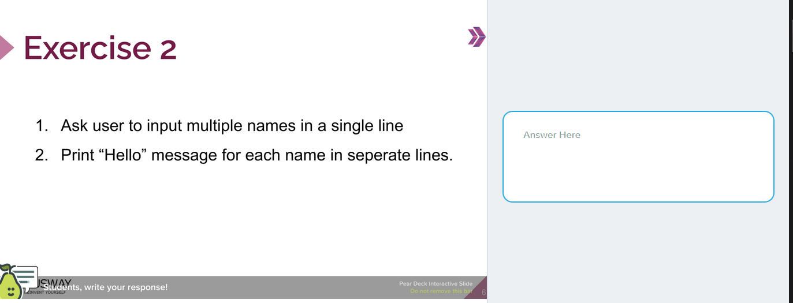#!/bin/bash  
read -p "Enter multiple names: " names  
for name in $names;  
do  
    echo "Hello $name"  
done

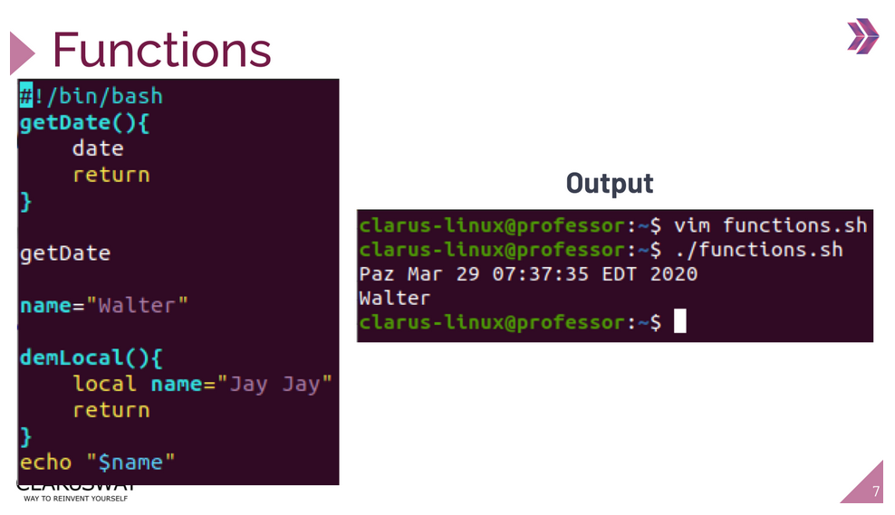

#!/bin/bash

getDate() {

date

return

}

getDate

name="Veysel"

localvariabletest() {

local name="Ugur"

return

}

echo "$name"

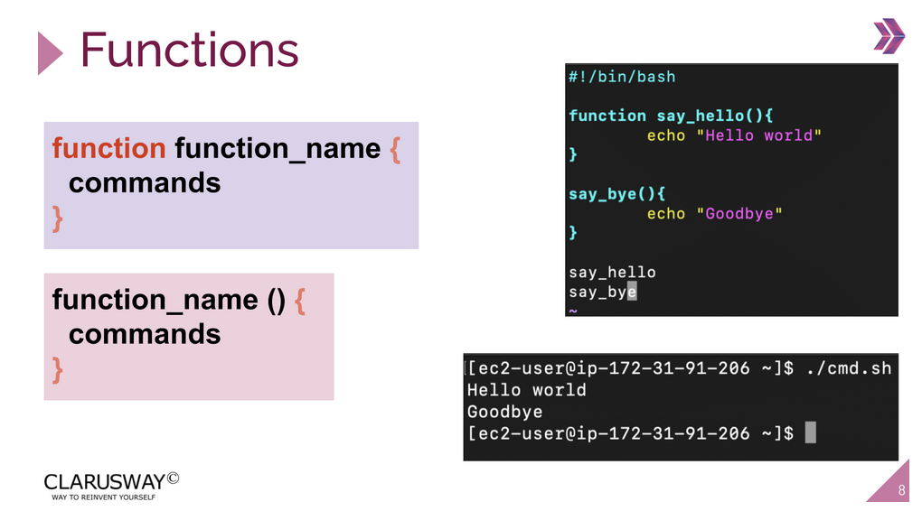

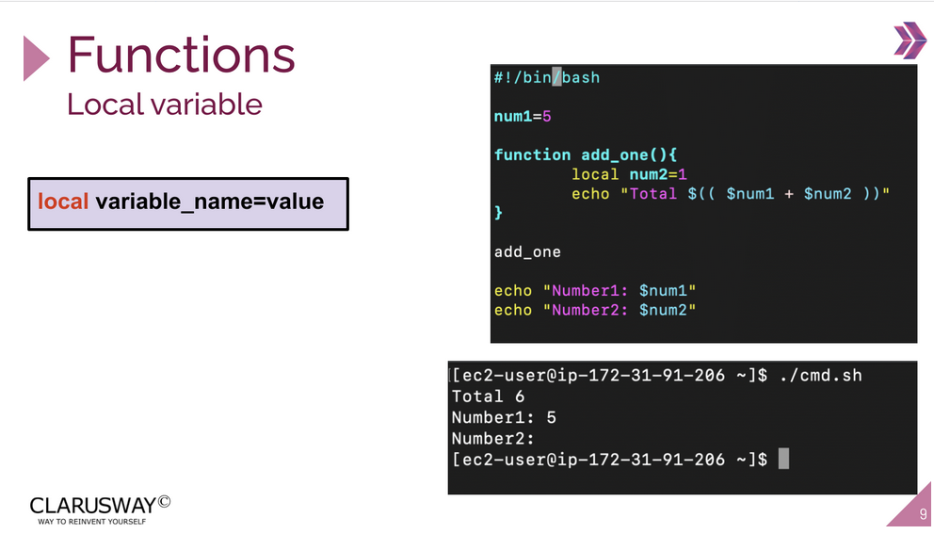

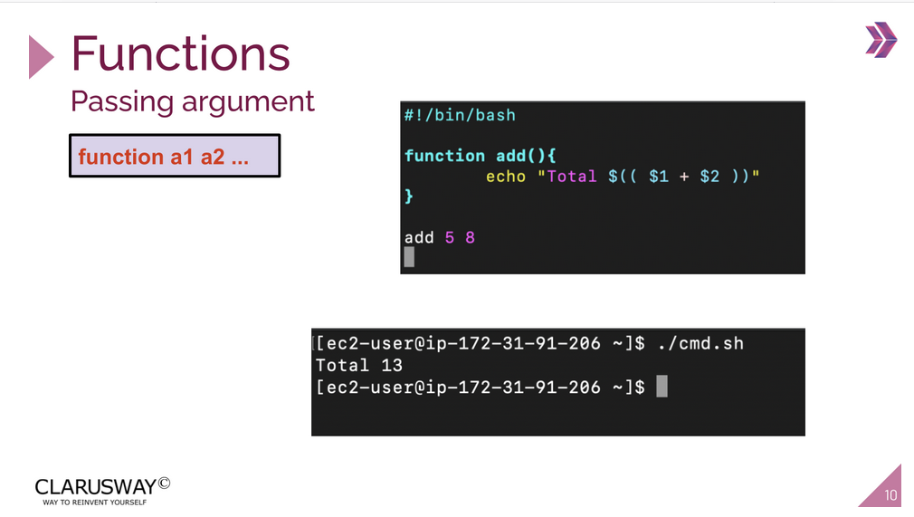

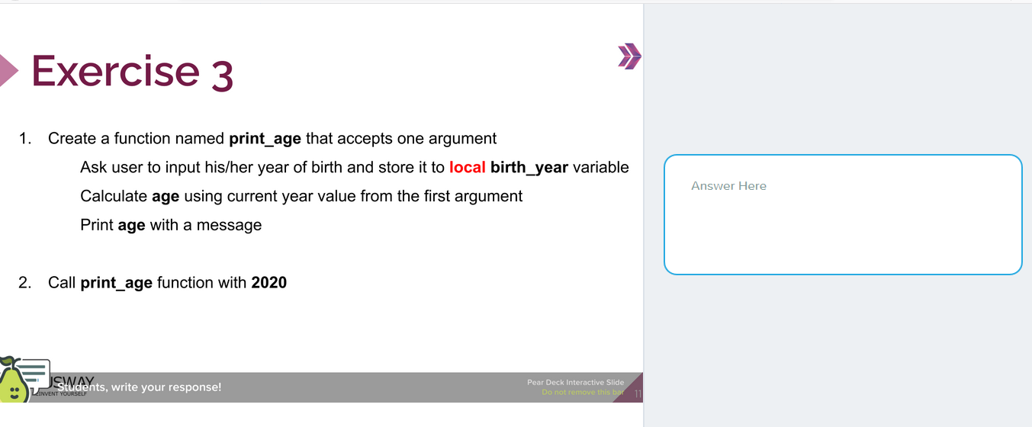

#!/bin/bash

Function print_age() {

Local birth_year

read -p "Enter your birthday year : " birth_year

age=0

let age=$1-$birth_year

echo $age

}

print_age 2020

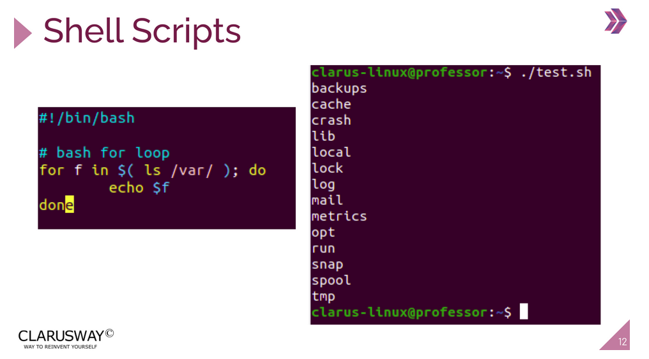

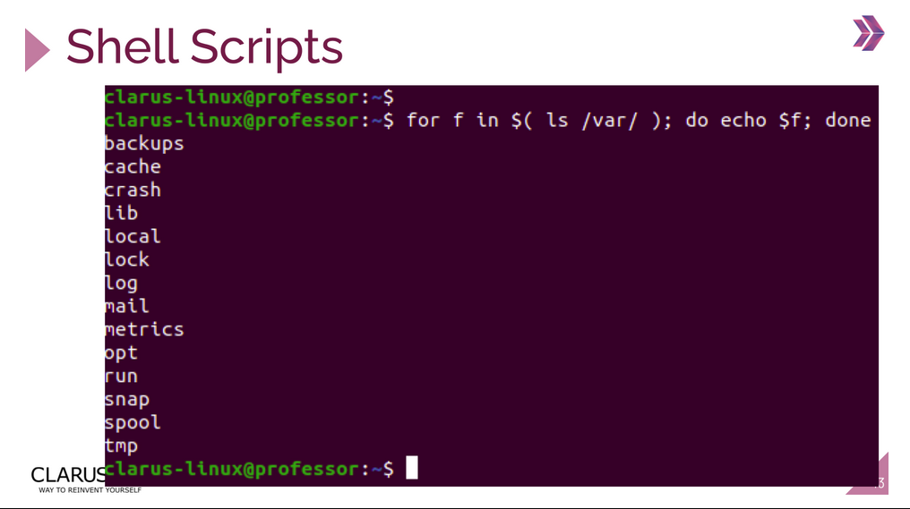

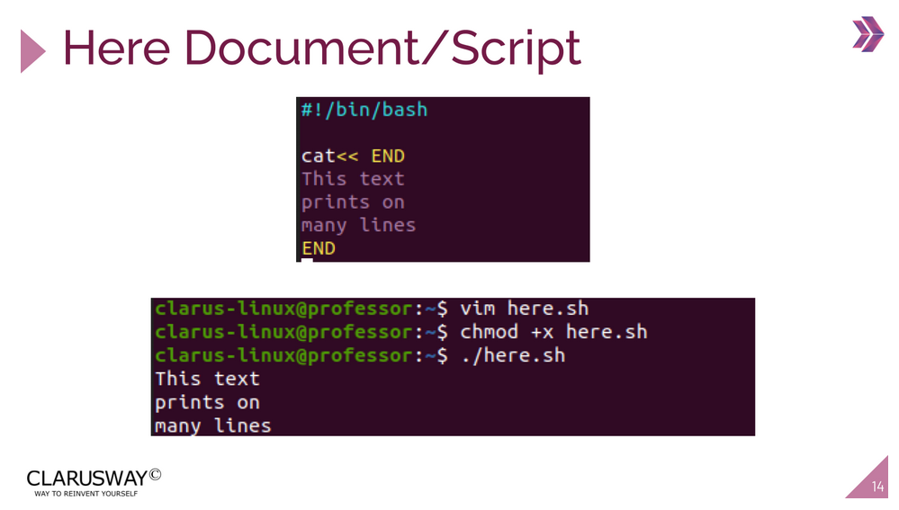

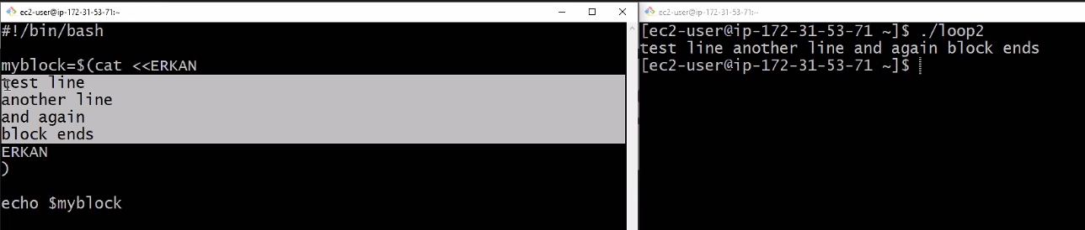

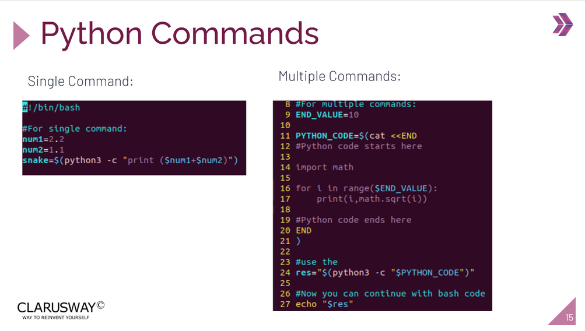

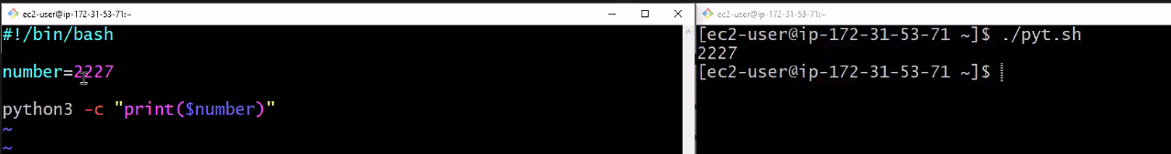

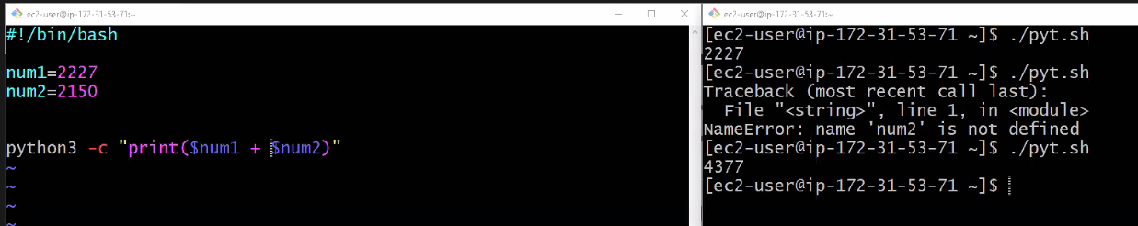

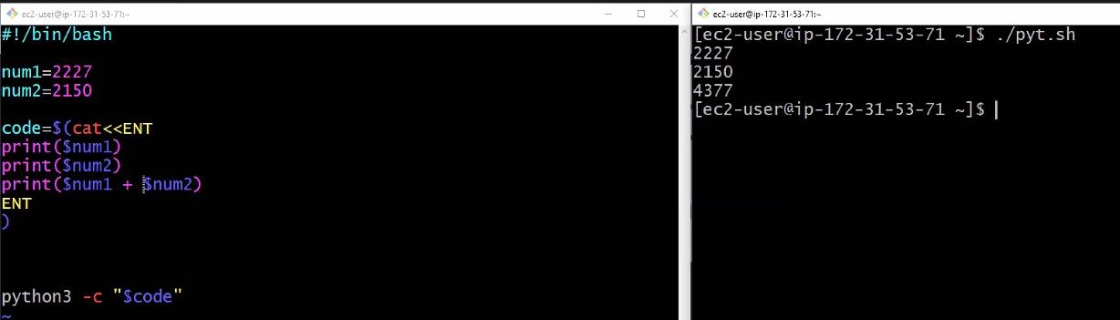

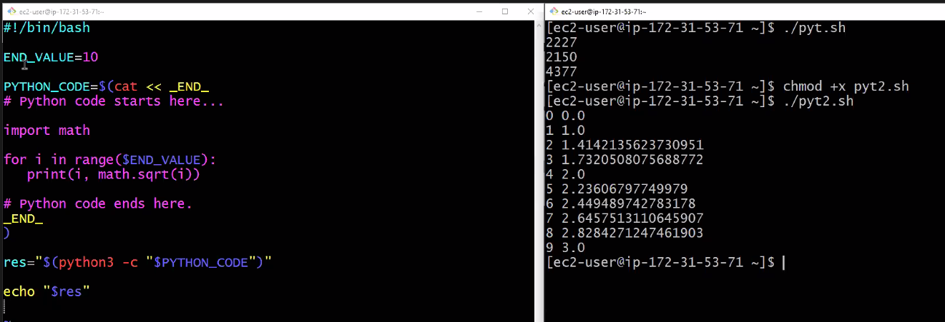

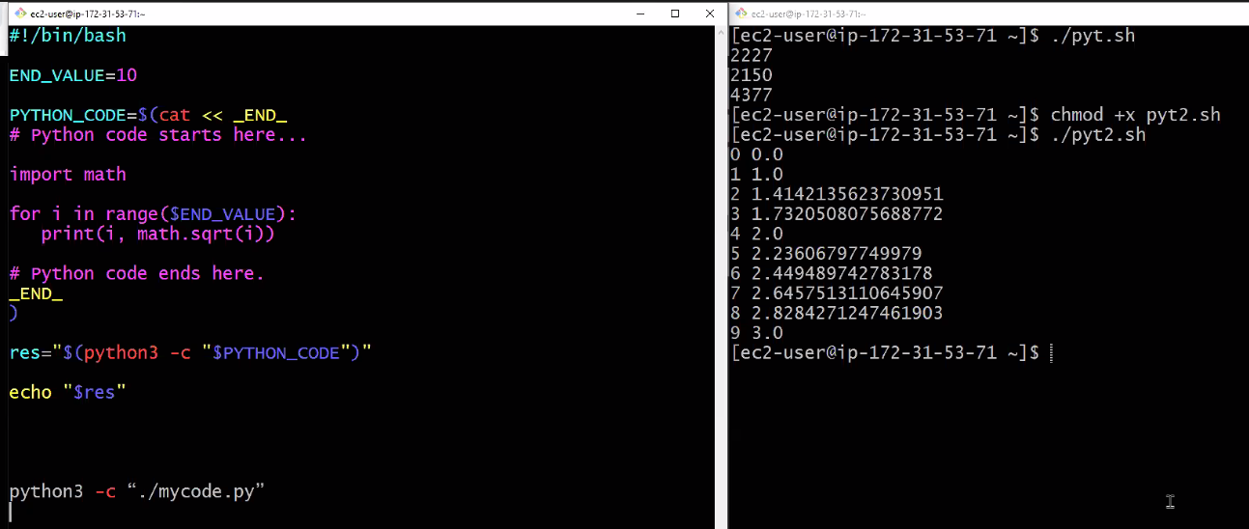

#!/bin/bash

number=5

python3 -c "print($number)"

***************

#!/bin/bash

num1=5

num2=4

python3 -c "print( $num1 + $num2 )"

******************

#!/bin/bash

n1=5

n2=4

code=$(cat <<END

print($n1)

print($n2)

print($n1 + $n2)

END

)

python3 -c “$code“

******************

python3 -c “./mycode.py”

**************

#!/bin/bash

END_VALUE=10

PYTHON_CODE=$(cat << _END_

# Python code starts here...

import math

for i in range($END_VALUE):

print(i, math.sqrt(i))

# Python code ends here.

_END_

)

res="$(python3 -c "$PYTHON_CODE")"

echo "$res"